Environmental Advisory Council
2023 Year End Review

Lower Makefield Township

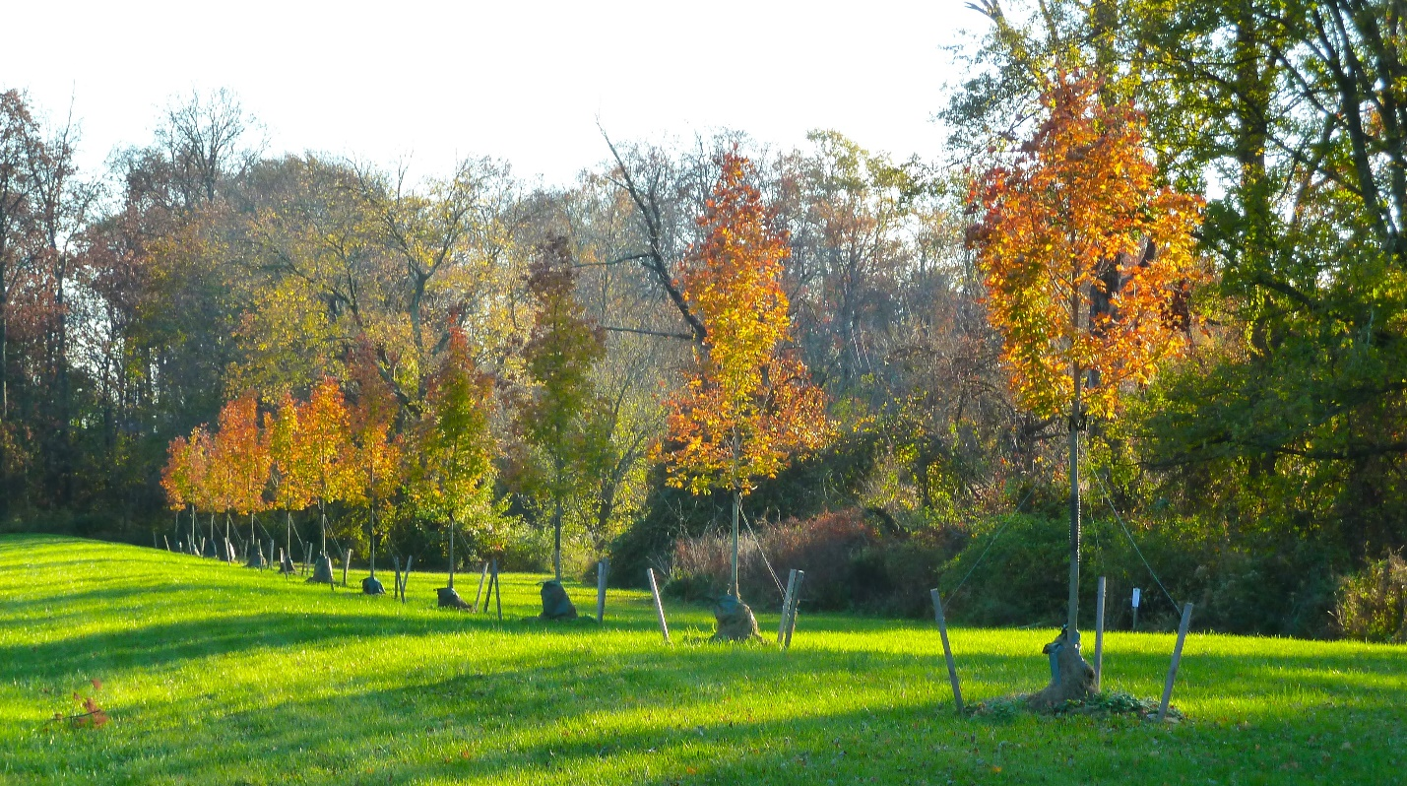
2023 Sugar Maple Tree Planting at Patterson Farm

To: LMT Board of Supervisors and Township Manager January 12, 2024
From: LMT Environmental Advisory Council
Subject: 2023 Year End Review

The Environmental Advisory Council (EAC) in LMT plays in important role in enhancing the quality of life for all citizens of our township. Accordingly, it is deemed important for us to prepare a Year End Review for the citizens and leaders of our community so that they may more properly assess the value we add to the quality of life in LMT. At the end of the document is a list of the projects we intend to pursue in 2024.
The EAC’s 2023 activities include the following:

- Recycling Events – The EAC hosted three very successful recycling events at the Township Building’s parking lot on January 14th, April 22nd and October 28th. In addition to Styrofoam, wine corks, household batteries, and prescription pill containers were collected. After the event the EAC transported the Styrofoam to Ray-Bob Packaging in Tullytown, PA for reuse in packaging. The collected prescription pill bottles are cleaned then mailed to an organization for re-use as medical supplies in Central and South America. The corks are reused in construction or as artwork. The batteries are taken to a local battery recycler where the metals are recovered.

- Other Recycling/Sustainablity Efforts – The EAC published a document entitled “2023 Recycling Guide” in February. Many everyday life items cannot be put into the residential curbside recycling bins. This guide lists where these items can be taken in the local community for recycling and/or reuse. EAC members have also started evaluating LMT community events to improve their sustainability.

- Tree Planting in the Township – As recommended in 2022 by the EAC, 30 sugar maples were planted in Allee fashion on Mirror Lake Road in March of 2023. Even the 1st year planting showed beautiful Fall color. On April 14th, the EAC sent a letter to the BOS recommending seven possible locations for planting trees in 2023 and beyond. In the fall of 2023, 162 trees were planted at three of the recommended sites (Memorial Park, Caoila Fields, and the Fred Allen Fields). The EAC inspection of these newly trees identified an inappropriate planting technique that was brough to the Township’s attention and corrected.

The EAC has worked with the Township’s hired consultant (Tom Comitta and Asso.) to develop a new long-range tree planting plan to replace the essentially completed 2016 plan. This plan should be completed in 2024. As part of its responsibilities, the EAC monitors developers’ contributions to the Tree Bank account and the projects where the money is spent. At the end of 2023, the Tree Bank account had $255,142. By the end of 2024 it is projected to have $427,270.
- Township Ordinances – The EAC has historically participated and commented on environmentally related revisions to the existing LMT ordinances. This year was no different.
Required Open Space for Residential Developments (Chapters 178 and 200) – A proposed revision to the SALDO and Zoning Ordinances would require at least 25 percent of residential development land in the R-RP, R-1, R-2 and R-3 zoning districts be designated as open space. The EAC strongly supports the concept of this ordinance and submitted an October 12th comment letter and a December 20th email with suggestions to improve and clarify the ordinance.

- Land Use Reviews – The EAC is designated a land use review board for the Township. In 2023, the EAC reviewed and provided comments on these six proposed developments:
  - 1566 LLC Subdivision - 21.7 acre parcel located near the intersection of Yardley-Newtown Road and Creamery Road, proposal for six new houses. Submitted comment letter dated February 10th on the Final Plan.
  - 1101 Big Oak Road – 5.75 acre site near Bohm Middle School, proposal to remove one existing house and build 6 new homes. The EAC submitted January 29th, March 10th, and May 14th comment letters on the Preliminary/Final plan.
  - The Point in Edgewood Village – 0.76 acre site with two existing houses, proposal build 13 housing units in five buildings with 28 space parking lot. The EAC submitted June 9th and October 12th comment letters on the proposed project.
  - Tolbert Farm Development – 78 houses on 108 acres. EAC submitted May 12th comment letter.
  - 1511 Lindenhurst - Subdivide an existing 4.5 acres lot into two, EAC submitted Oct 12th comment letter.
  - Edgewood/Sandy Run Rd Timko Subdivision – Subdivision of 4.17 acre parcel into two lots with two housed. EAC Dec 15th comment letter submitted.

- Open Space – Encouraging the Township to preserve and protect LMT’s remaining open space is one of the EAC’s principal efforts. To that end, the EAC sent a June 15th letter to the BOS entitled “2023 Ballot Referendum for Open Space and Farmland Preservation”. Such a referendum would authorize the Township to borrow up to $15 million for the proposes of purchasing or placing easements on open space land. No action was taken by the BOS. As has been the case since 2017, no additional open space in the township was purchased or preserved in 2023.

- Reactivation of Bird Town PA – The EAC took steps to reactivate LMT’s membership in Bird Town PA. At the EAC’s request on December 6th the BOS passed a resolution reaffirming LMT’s membership and supporting environmental projects encouraged by Bird Town.

- Community Outreach - Reaching out to LMT residents is an important EAC goal. This goal is achieved in several different ways.

Environmental Lecture Series and Outreach – The following EAC Environmental lecture were held in 2023:
Monarch Butterflies and the Miracle of Migration lecture was held on June 10th at the Township Building. Mike Weilbacher discussed the life cycle and migration of the monarch butterfly from northern U.S. to Mexico. Free milkweed plants were given out to attendees.
Newsletter – The EAC Newsletter is published on an as needed basis with special announcements for events such as Recycling Events and EAC lectures and information on various environmental topics. It is sent to over 300 LMT and 300 non-LMT residents on our e-mail lists.

- Environmental Stewardship Award – The Environmental Stewardship Award Program is an EAC initiative that started in 2008. It has not only recognized the merit of the award winners but has resulted in very favorable publicity for LMT as well. The 2023 award was given to the group of Master Gardeners maintaining the LMT Native plant Demonstration Garden. The garden is outside the Township Building along Edgewood Road. The group maintains the garden and plant native plants to provide habitat and food for pollinators and birds. It also educates the LMT community about the value of native plants. The award ceremony will be held at a BOS Meeting in late January or Feb. 2024.

- Participation in Outside Committees – EAC members have joined outside committees that requested the EAC’s input. These committees include the Ad Hoc Property/Patterson Farm Master Plan Committee and the Pennsbury School District’s Sustainability Committees.

The following is a list of projects that the EAC intends to pursue in 2024:
- Bird Town PA – Help assemble a Bird Town committee, identify possible Bird Town projects and assist in their implementation.
- Township’s new Long Range Tree Planting Plan - Continue providing input into the document that is currently being developed with the assistance of Tom Comitta and Asso.
- Tree Bank Payments and Expenditures – The EAC will continue to ensure money owed to the Township’s Tree Bank is paid on a timely basis and spent in an appropriate way.
- Single Use Plastics Ban – We have already started to explore this incredibly important project. We feel that this is an idea whose time has come. Newtown Township, as well as many other States and local municipalities have enacted such bans. Successful ordinances in other municipalities will be reviewed and an ordinance for LMT will be drafted. The goal is to have an ordinance in place in 2024.
- Single Trash Hauler – In 2008 the EAC proposed a Single Trash Hauler Systemin LMT because of the efficiencies and environmental benefits. Because of pressure of outside interests hired by the trash haulers, this program was not adopted then. Based on recent positive input from citizens and Township officials the EAC feels this program should be a topic of discussion in 2024. The EAC has pertinent information as to how such a program can be judiciously introduced.
- Strengthen the Township’s Basin Naturalization Program.
- Open Space and Farmland Preservation Referendum - Continue to advocate for ballot referendum that would fund open space and farmland preservation.
- Environmental Lecture Series – The EAC is hoping to have a lecture regarding native edible and medicinal plants. The lecture would be given by Jared Rosenbaum of the Tupenhaking Nature Center in NJ.
- Recycling Collection Events – As in the past, have three Styrofoam/battery/ prescription bottle/cork collection events in 2024. One is scheduled on Jan. 20, 2024.
- Tree City USA - Explore the possibilities of LMT joining Tree City USA. This would include determining the actions the Township would have to take to join and assist in this effort.
- Implementation of past LMT commitments to clean power purchasing.
It is our steadfast opinion that the EAC’s projects translate not only to a better environment in the Township, but also, to economic savings for the citizens of LMT. As always, it is both a privilege and a pleasure to serve the people of Lower Makefield Township.
Sincerely,
The LMT EAC: Alan Dresser – Chair; Matt Farrell, Vice-chair; Kevin Gallen – Member; Jim Bray, Member; Paul Roden, Member; Soumya Dharmavaram, Member; Linda Salvati – member.

