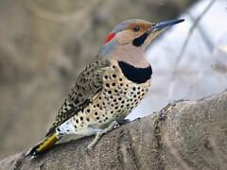
LMT Bird Town Bird of the Month:

🪶 Northern Flicker – Cool Facts
- Unlike most woodpeckers, Northern Flickers spend lots of time on the ground, hunting ants and beetles.
- They can eat thousands of ants in a single day, using a long, barbed, sticky tongue.
- Their slightly curved bill is adapted for digging in soil instead of drilling wood.
- In flight, they flash a bright white rump patch and colorful wing linings (yellow or red depending on the form).
- There are two main types—Yellow-shafted and Red-shafted—which often interbreed where their ranges meet.
- Flickers often reuse tree cavities and their old nest holes become homes for other birds and wildlife.
- Their loud “wicka-wicka-wicka” call is easier to hear than their drumming.
- Males perform aerial courtship displays to defend territory and attract mates.
- Some flickers migrate, while others stay year-round depending on location and food supply.

A truly unique woodpecker you’re just as likely to spot on your lawn as on a tree! 🌳

